ASSIGNMENT – 02
- Draw a labelled diagram of a typical home Wi-Fi router and a network switch, clearly marking at least 3 different ports (such as WAN, LAN, Console) and the location of status LEDs.
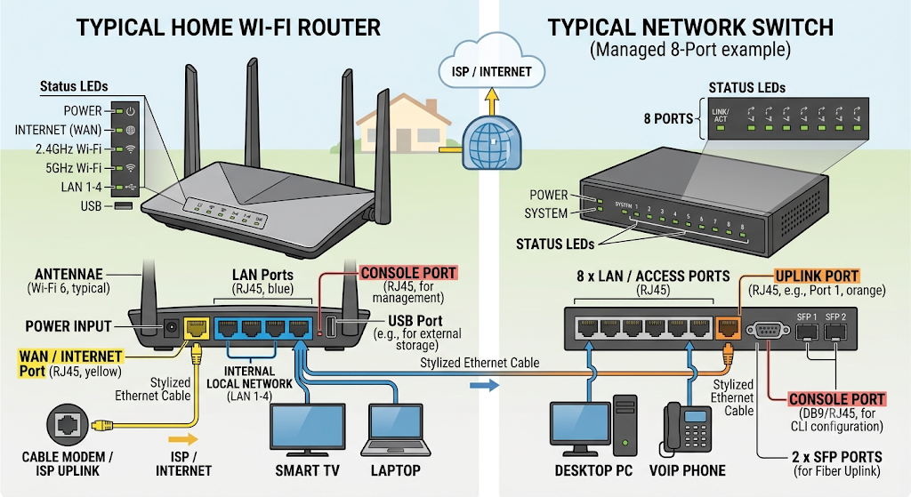

- List 3 key differences between routers and switches in terms of their main functions and how they handle network traffic.<br><br><em><strong>Hint:</strong> Think about how each device deals with IP addresses, MAC addresses, and the types of networks they connect.</em>

No. | Router | Switch
1. Address Used | Uses IP addresses to decide where to send data. | Uses MAC addresses to forward data to the correct device.
2. Main Function | Connects different networks and routes traffic between them. | Connects multiple devices within the same network (LAN).
3. Traffic Handling | Sends data packets between different networks based on their IP addresses. | Forwards data frames to the specific device in the LAN based on its MAC address.

- Take a real or virtual image of a router and a switch (from your home, lab, or Google Images), and identify the following on each: Power port, at least 2 Ethernet ports, and any LED indicators. Annotate the image or describe their position and purpose.

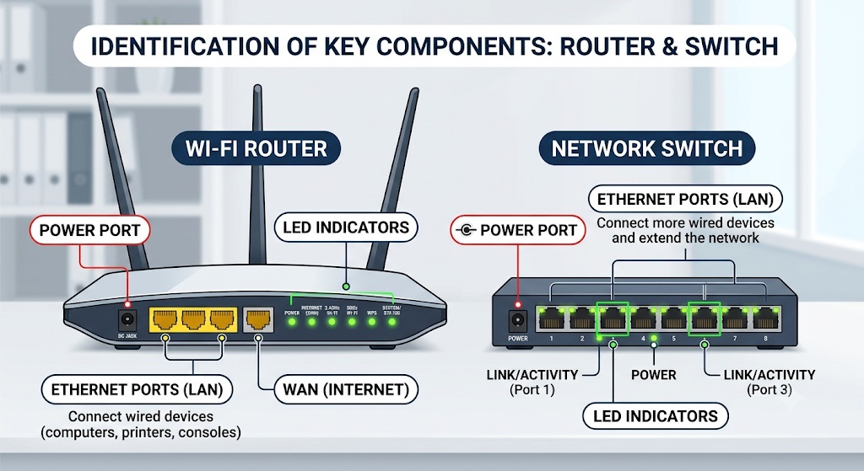

- Imagine you are setting up a small gaming café network for IPL streaming and multiplayer matches. Write a short scenario explaining which device (router or switch) you would connect first to the ISP line, and how you would connect 8 gaming PCs to the network. Justify your choices.

Small Gaming Cafe Network – Step-by-Step
Step 1: Get an Internet connection from an ISP for the gaming cafe.

Step 2: Connect the ISP line to the router.
- The router receives the Internet connection.
- It manages and directs network traffic.

Step 3: Connect the router to a network switch using an Ethernet cable.

Step 4: Connect Gaming PC 1 to Gaming PC 8 to the switch using separate Ethernet cables.

Step 5: Configure the router so that all 8 PCs can access the Internet.

Step 6: Test the network by checking Internet access and multiplayer connectivity on all 8 PCs.

Network Connection
ISP → Router → Switch → 8 Gaming PCs

